Free Ride Bicycle Project
A Pennsylvania Nonprofit Corporation

BYLAWS

ARTICLE I—PURPOSES

1.1 The purposes of the Corporation are as set forth in its Articles of Incorporation pursuant to the Pennsylvania Nonprofit Law of 1988 (The Act).

1.2 The mission of Free Ride Bicycle Project is to enable people of all ages to obtain, recycle and maintain bicycles. Free Ride Bicycle Project aims to enhance the health of our community and environment by promoting bicycle transportation.

1.3 Free Ride Bicycle Project's core goals, principals, and values are: (a) to strive to operate in the most directly democratic and minimally hierarchical way possible; (b) to be respectful of all people; (c) to be supported and operated by the community of people who use it; (d) to respect and encourage all shop visitors to learn regardless of their experience level or background; and (e) for all participants to benefit from, and in return, give back to the Free Ride Bicycle Project community in some way.

ARTICLE II—OFFICE

2.1 The registered office of the Corporation shall be 214 N. Lexington Street, Pittsburgh, PA 15208, or such other location in Pennsylvania as the Collective Council may from time to time determine.

2.2 The Corporation may also have offices at such other places as the Collective Council may select and the business of the Corporation may require.

ARTICLE III—MEMBERS

3.1 Number and Dues. The Corporation shall have two classes of memberships consisting of Standard Member and Collective Council Member.

3.2 Requirements for Membership. Membership is open to all people who share the values and goals of the Corporation and who meet the following commitments:

3.2.1 Standard Members shall volunteer four (4) hours per quarter for the Corporation.

3.2.2 Collective Council Members: In order to be eligible for Collective Council Membership, members shall, in the 6-month period preceding their term,
(a) volunteer thirty-two (32) hours for the Corporation
(b) participate in at least at least 50% of the Collective Council meetings and at least one Committee meeting and (c ) receive vote of approval from each current council member.

3.3 Membership Term. All membership is limited to term conditions. Membership is terminated at the end of the term duration. Membership is reinstated when the requirements to membership are completed as defined in section 3.2. An individual may be a member or council member an unlimited number of terms.

3.3.1 Fixed term duration. Membership is limited to a fixed duration.
The membership term duration is as follows:

3.3.1.1 Standard membership has terms of 3 months beginning when the individual establishes membership and terminating at the end of the current quarter.

3.3.1.2 Council membership has terms of 6 months.

ARTICLE IV – GOVERNANCE

4.1 Governing Body. Free Ride's governing body shall be the Collective Council.

4.2 Qualifications of Collective Council Members. Each member of the Collective Council shall be a natural person of full age, who need not be a resident of Pennsylvania, who has fulfilled the requirements of a Collective Council Member as described in Section 3.2.2.

4.3 Number of Collective Council Members. The Collective Council shall consist of no less than three (3) Collective Council members. There is no maximum number of Collective Council members, unless otherwise determined by the Collective Council.

4.4 Positions within the Collective Council. The positions of the Collective Council shall include a Facilitator (President), a Note-taker (Secretary), and a Treasurer and such other positions which may be created from time to time by the Collective Council. Authority not expressly granted to individuals holding these positions shall be reserved for the Collective Council.

4.5 Duties and Authority. The duties and authority granted to the Collective Council members holding the above positions are as follows:
(a) Facilitator. The Facilitator shall have the authority to receive, open, and forward to the Collective Council all correspondence from Local, State, and Federal Governments, other taxing authorities, or regulatory agencies traditionally addressed to the “President of the Board,” and to add action on such correspondence to the agenda of the Collective Council.
(b) Note-taker. The Note-taker shall have the authority to receive, open, and forward to the Collective Council all correspondence from Local, State, and Federal Governments, other taxing authorities, or regulatory agencies traditionally addressed to the “Secretary of the Board,” and to add action on such correspondence to the agenda of the Collective Council. The Note-taker shall be responsible for (1) keeping the official minutes of Collective Council Meetings or delegating such responsibility to another Collective Council Member; (2) for keeping such records organized; and (3) for responding to requests for access to such documents as required by law.
(c) Treasurer. The Treasurer shall have the authority to receive, open, and forward to the Collective Council all correspondence from Local, State, and Federal Governments, other taxing authorities, or regulatory agencies addressed to the Treasurer and to add action on such correspondence to the agenda of the Collective Council. Further, the Treasurer shall respond to requests for access to the financial documents of the Corporation as required by law.

4.6 Decision Making Authority. Decisions reserved to the Collective Council Members at Collective Council meetings are those dealing with membership; disposition and acquisition of assets; all matters regarding debt or credit; Bylaws; Articles of Incorporation; agreements, partnerships, or other relationships with outside Corporations; employees and employment policies; leaves of absence; expulsion; dissolution; and any other matters which the Collective Council Members may deem necessary to decide.

4.7 Decision Making Process. The Collective Council shall use the consensus decision making process (See Attached Appendix) for all matters except the expulsion or revocation of members.

4.8 Collective Council Meetings. The Collective Council shall meet a minimum of four times per year with additional meetings to be determined by the Collective Council. All Collective Council meetings shall be within reasonable bicycling distance of Corporation's primary physical location (“the shop”).

4.9 Proxy. Any Collective Council Member that does not attend a meeting may submit their thoughts or feelings about a matter under consideration to the Collective Council or Committee in advance. The members at the meeting are expected, but not required, to take these thoughts and feelings into consideration when making decisions.

4.10 Quorum. A majority of the current members of the Collective Council shall constitute a quorum for the transaction of business at any meeting and the acts of the Collective Council members present at the meeting at which a quorum is present shall be the acts of the Collective Council, unless otherwise required by law or by these bylaws.

4.11 Expulsion of Members and Revocation of Membership. Decisions regarding the expulsion of members and the revocation of membership may be made only by the Collective Council. In such matters, the individual whose membership is subject to expulsion or revocation shall not have the right to block the expulsion or revocation decision.

ARTICLE V—SEAL

5.1 The Corporate Seal shall be in circular form and shall bear the name of the Corporation and the words “Corporate Seal, Pennsylvania 2010.”

ARTICLE VI—COMMITTEES

6.1 The Collective Council may establish, after consensus on such a proposal, one or more committees consisting of one or more Collective Council Members. The goal of such committees shall be to carry out tasks expressly assigned to it by the Collective Council.

6.2 Authority granted to Committees. No committee has authority or power to reach decisions not expressly granted to it by the Collective Council. No committee may ever be granted any of the authorities or powers articulated in Section 4.6, which are exclusive to the Collective Council. All actions of a committee are subject to review and recall by action of the Collective Council. All committees must report on their actions and activities at Collective Council Meetings, and fulfill any other reporting or transparency requirements or policies as the Collective Council may create or as required by law.

ARTICLE VII—MEETINGS AND NOTICE

7.1 Place of Meetings. Meetings shall be held at such place as the Collective Council may from time to time determine, or as may be designated in the notice of the meeting. All meeting locations shall be such a distance from Corporation’s primary physical location (“The Shop”) to be reasonably accessible by bicycle.

7.2 Notice. It shall be the responsibility of both Standard Members and Collective Council Members to maintain an electronic mail (e-mail) address, subscribe to the Corporation’s email-based notification lists, and manage their account(s) on the Corporation's email-based discussion and notification lists. Official notices of meetings will be delivered via an email announcement list designated by the Collective Council. Such notice shall specify the place, date and time of the meeting and the general nature of the business to be transacted. Failure of members to maintain an email address and manage their subscriptions to the Corporation's email lists shall be considered a waiver of notice by such an individual otherwise entitled to such notification, but shall in no other way effect said individual's eligibility for membership in the Corporation.

ARTICLE VIII—INDEMNIFICATION

8.1 General Rule. For the purposes contained in 15 Pa.C.S.A. § 513, any Collective Council Member who takes on responsibility for a particular aspect of the Corporation's business shall be considered a “Director” of the Corporation and shall not be personally liable for monetary damages for any action taken, or any failure to take any action, as specified in 15 Pa.C.S.A. § 513, unless:
(a) the Director has breached or failed to perform the duties of Director in accordance with the standard of conduct contained in Section 8363 of Subchapter F of Chapter 83 of Title 42 of the Pennsylvania Consolidated Statutes and any amendments and successor acts thereto; and
(b) the breach or failure to perform constitutes self-dealing, willful misconduct or recklessness;
Provided however, the foregoing provision shall not apply to (a) the responsibility or liability of a Director pursuant to any criminal statute or (b) the liability of a Director for payment of taxes pursuant to local, state or federal law.

8.2 Indemnification. The Corporation shall indemnify any member, employee, or other representative of the Corporation who was or is a party or is threatened to be made a party to any threatened, pending, or completed action, suit or proceeding, whether civil, criminal, administrative or investigative, and whether or not by, or in the right of, the Corporation by reason of the fact that such person is or was a representative of the Corporation, against all expenses including attorney fees, judgments, fines and amounts paid in settlement as to actions taken, or omitted to be taken, in such person's official capacity as representative or agent of the Corporation and as to actions taken, or omitted to be taken, in another capacity while holding such official capacity, or in such person's capacity as employee or representative provided, however, that no persons shall be entitled to indemnification pursuant to this Article in any instance in which the action or failure to take action giving rise to the claim for indemnification is determined by a court to have constituted willful misconduct, or recklessness.

8.3 Advancement of Expenses. Expenses incurred by a person entitled to indemnification pursuant to this Article in defending a civil or criminal action, suit or proceeding shall be paid by the Corporation in advance of the final disposition of such action, suit or proceeding upon receipt of an undertaking by or on behalf of such person to repay the amount so advanced if it shall ultimately be determined that such person is not entitled to be indemnified by the Corporation.

8.4 Continuing Right to Indemnification. The indemnification and advancement of expenses provided pursuant to this Article shall continue as to any person who has ceased to be member or employee or representative of the Corporation and shall inure to the benefit of the heirs, executors and administrators of such person.

8.5 Other Rights. This Article shall not be exclusive of any other right which the Corporation may have to indemnify any person as a matter of law.

ARTICLE IX—AMENDMENTS

9.1 The Articles of Incorporation and the Bylaws of the Corporation may be amended by consensus of the Collective Council at two duly-convened meetings which are no less than thirty days apart.

ARTICLE X—MISCELLANEOUS

10.1 Fiscal Year. The fiscal year of the Corporation shall begin on January 1st and end on December 31st.

10.2 Headings. In interpreting these Bylaws, the headings of articles shall not be controlling.

10.3 Bond. If required by the Collective Council, any person shall give bond for the faithful discharge of his or her duty to the Corporation in such sums and with such sureties as the Collective Council shall determine.

10.4 Subventions. The Corporation shall be authorized, by resolution of the Collective Council, to accept subventions on terms and conditions not inconsistent with the Act and to issue certificates therefore.

ARTICLE XI—DISSOLUTION

11.1 On dissolution of the corporation or the winding up of its affairs, the assets of the Corporation shall be distributed exclusively to a nonprofit bicycle organization which qualifies under the provisions of Section 501(c)(3) of the Internal Revenue Code. If no bicycle organization is available, the assets of the Corporation shall be distributed exclusively to a charitable, religious, scientific, public-safety testing, literary, or educational organizations that would then qualify under the provisions of Section 501(c)(3) of the Internal Revenue Code.

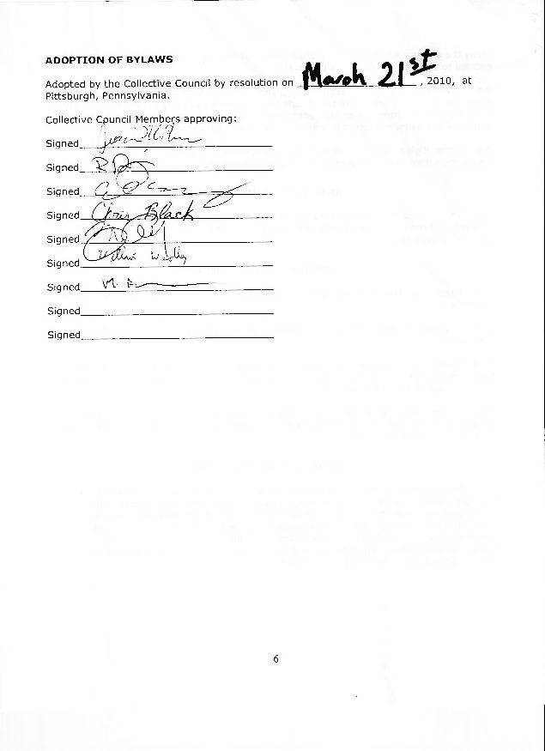
APPENDIX

Free Ride Bicycle Project
Consensus Decision Making Process

The Consensus Decision Making Process is a process used to make decisions, wherein all participants must consent before action is taken. The spirit of consensus includes a shared understanding of why it makes sense to move ahead with a particular proposal. The process seeks to synthesize the wisdom of the group to produce the highest quality decision possible.

Definitions:

- Support. A term used in the consensus decision-making process for those who agree with and support proposed decision.
- Stand Aside. A term used in the consensus decision-making process to describe the action of those who are willing to let the group (including themselves) go forward with a proposed decision, but find themselves significantly not in alignment or holding substantial concerns about the proposed decision.
- Block. A term used in the consensus decision-making process by someone who feels called to stand in the way of a proposed decision because that person believes the group is making an extremely unwise, irresponsible, or immoral decision, or one in conflict with the basic purpose for the group’s existence.
- Vote. Any time a Collective Council member agrees with and supports, stands aside from, or blocks a decision using the consensus process.

