Education Not Deportation:
The Struggle for Access without Fear to Education


CONTENTS

Education Not Deportation

Toronto District School Board 2
Profile: Kimberly and Gerald Lizano-Sossa 4
Profile: Matthew Nguyen and Rawad Reda 6
The Struggle Continues: Implementation, 11 Expansion, and Post-Secondary Education
Profile: Sarah Leonty and Saad Alam 13

Discussion Questions and Activities

Discussion Questions 18
Activities 19
Further Resources: Articles and Reports 21
Further Resources: Websites 22

Education Not Deportation

Toronto District School Board

On April 27, 2006, 15-year-old Kimberly Lizano-Sossa and her 14-year-old brother Gerald were pulled out of school by immigration enforcement officers and taken into custody in an attempt to apprehend their father. Public outcry sparked a massive campaign to prevent the deportation of the Lizano-Sossa family, but also to institute wider changes to make schools safe spaces where students wouldn’t have to fear the threat of deportation.

The Lizano-Sossa family was deported to Costa Rica on Canada Day 2006, but before their deportation, community mobilization resulted in the introduction of the “Don’t Ask, Don’t Tell” (DADT) policy at the Toronto District School Board (TDSB). The policy states that school employees cannot ask about a student’s immigration status, and that if a school obtained this information, it would not be told to immigration officials. In addition, immigration enforcement officers are prohibited from entering schools.

The DADT policy upholds Section 49.1 of the Ontario Education Act, which states that any resident student, including “persons unlawfully in Canada”, has “the right, without payment of a fee, to attend a school.” The policy is meant to ensure access to education for all students, but experience has shown that just creating a policy is not enough. We need to be active to make access without fear a reality.
Profile:
Kimberly and Gerald Lizano-Sossa

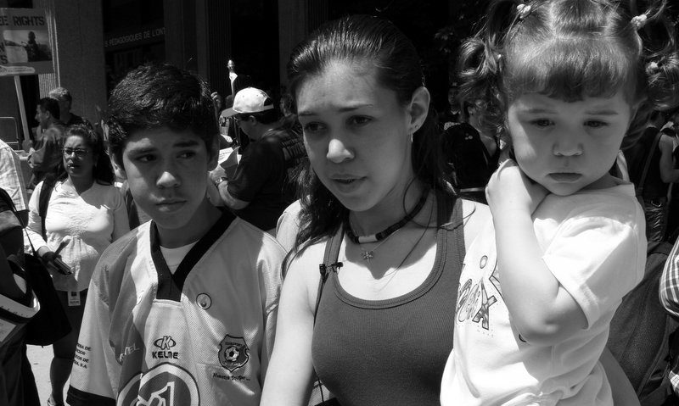

Kimberly and Gerald Lizano-Sossa were arrested by Canada Border Service agents. Dragged out of their classroom, they were tossed into a van where they found their mother, grandmother and Canadian-born baby sister, and driven to an immigration jail. Upset, enraged and scared, one of their classmates started making phone calls and was eventually directed to No One Is Illegal – Toronto (NOII). Members of NOII met with the students, teachers and administrators of the school who wanted to protest these arrests. The next day, we organized a gathering of over 70 people outside the detention centre demanding the Lizano-Sossa family’s release.

When the family stepped out of the detention centre, Kimberly boldly spoke out, “What happened to us was not fair. We deserve the right to stay here. Our home is here. Our friends are here. Our life is here. But this isn’t just about us. No one should be treated this way.” Her words became the rallying cry for mobilizations across the city.
Profile:
Matthew Nguyen and Rawad Reda

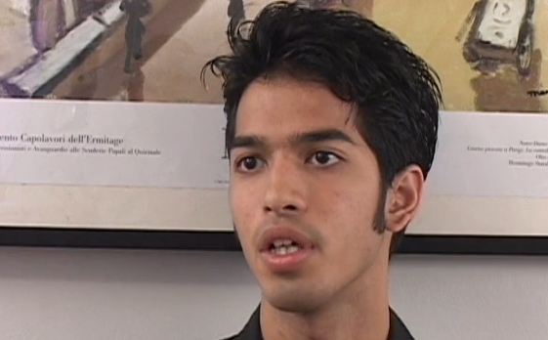

In July 2006, Matthew Nguyen, an 18-year-old student at Jarvis Collegiate was faced with a deportation order. Matthew, who was born in France, came to Canada at the age of 10 after his mother died to live with relatives. Not knowing whether or not his status in Canada would be questioned, Matthew’s relatives never enrolled him in school. However, at the age of 16 Matthew was determined to get an education – he left home and began attending classes at Eastdale Collegiate. He later transferred to Jarvis.

When Matthew applied for immigration status on Humanitarian and Compassionate grounds, his application was denied. Being forced to leave Canada would have been detrimental to Matthew, who spoke minimal French, and had no support system in France. In his appeal to stay, Matthew spoke about the importance of being able to finish his education in Canada. "I am just asking to give me a chance to stay and at least to finish my education, something that I have longed for, something that I was hoping I could at least have done," he said.

In an effort to overturn the deportation order, staff and students worked with organizations like NOII, the Toronto Youth Cabinet, and the Ontario Secondary Schools Teachers’ Federation District 12 (Toronto) to help raise awareness about the injustice Matthew was facing. Due to the mass amount of public support that Matthew received, immigration officials reversed their decision and Matthew was able to gain immigration status and complete his studies at Jarvis.

Shortly after Matthew’s victory, a former classmate of his at Jarvis, Rawad Reda, was served with a deportation order. Rawad, 18, graduated from Jarvis in June and was accepted to Georgian College for the fall. His world was turned upside-down when his Study Permit extension was rejected without any reasons given and he was told to voluntarily leave Canada immediately or enforcement actions would be taken.

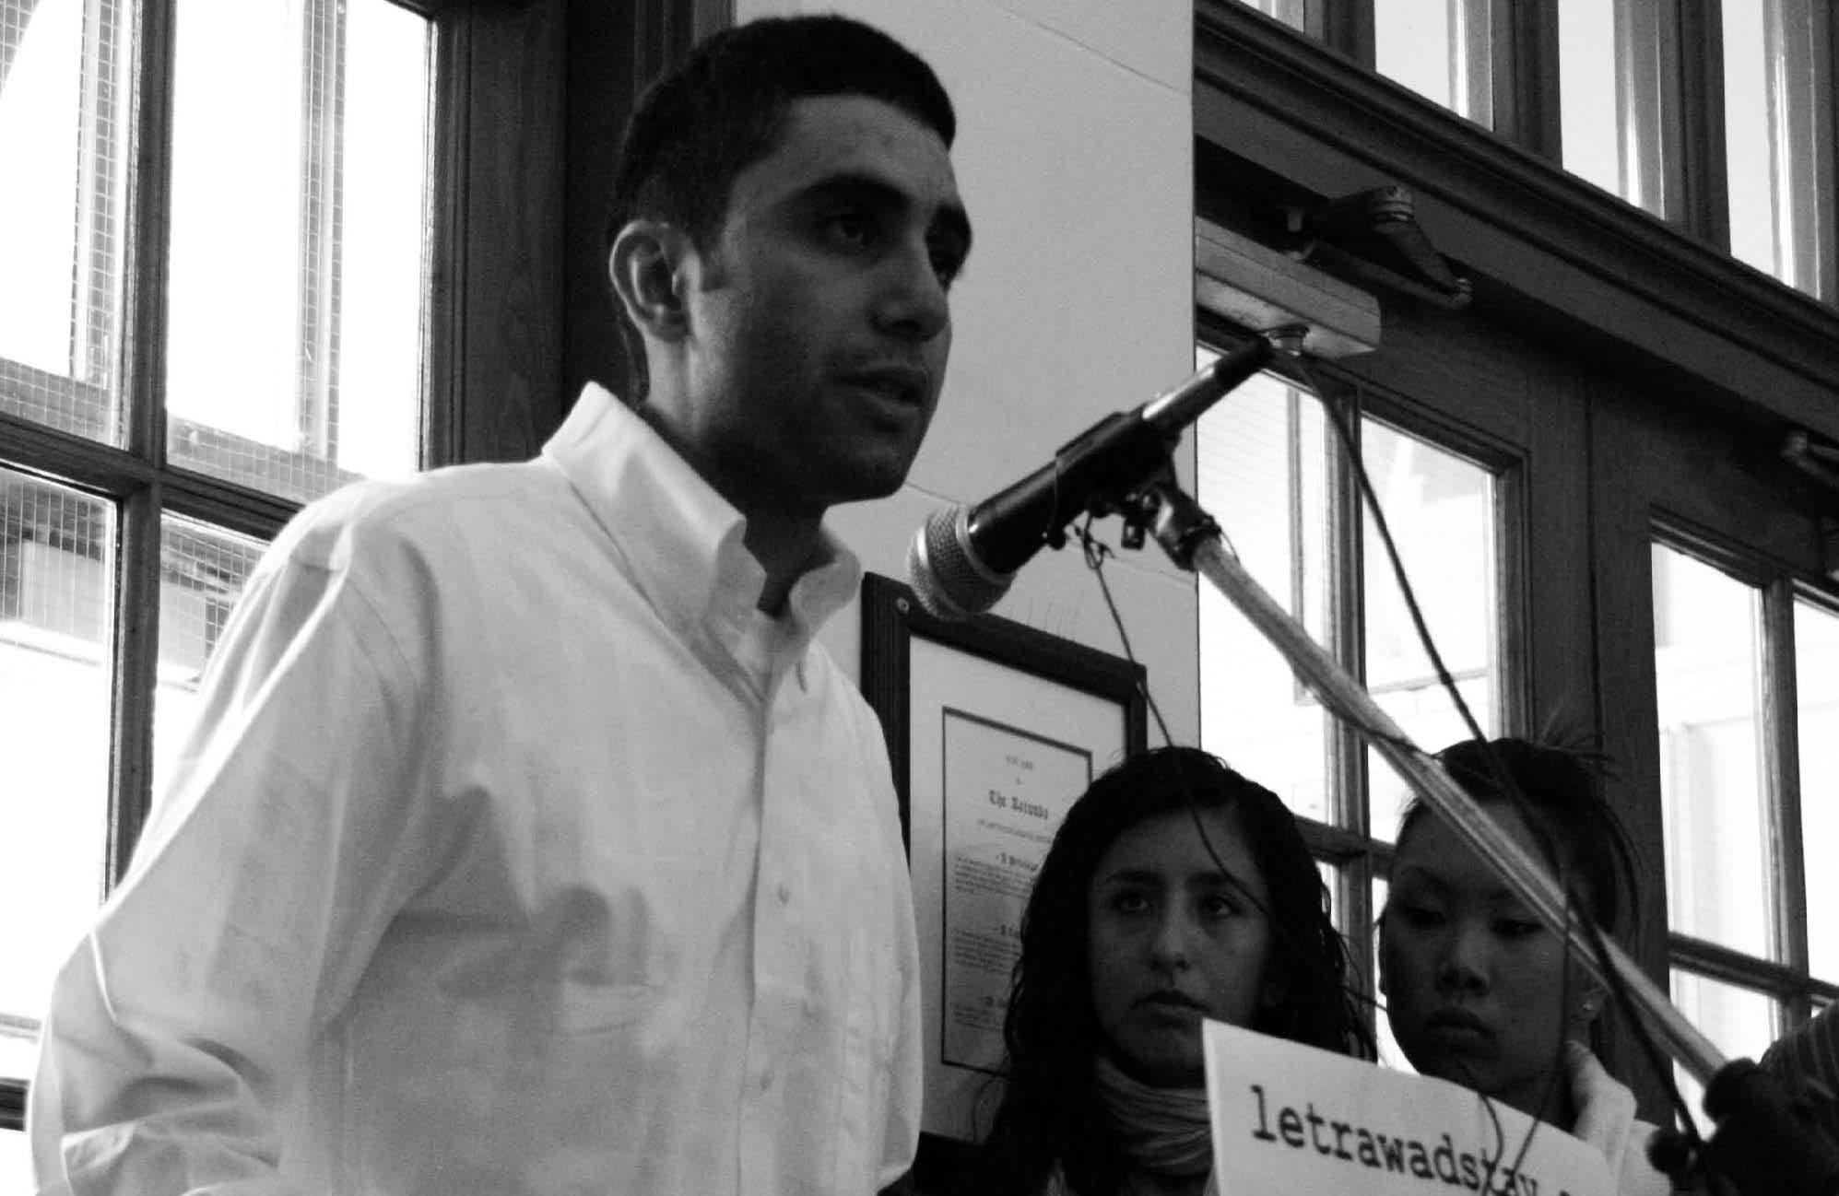
Rawad faced removal to a village in Lebanon, Aita el Chaab, where he had no immediate family and that was largely destroyed due to bombings by the Israeli military in the summer of 2006.

With the support of teachers and students at Jarvis, over 100 people attended a lunch-time rally and press conference in the school lobby that made local and national media headlines. 578 messages of support addressed to the Minister of Immigration were posted on the www.letrawadstay.com website created for Rawad by a friend. Supporters continued to apply pressure and ultimately it was too much for the Minister to ignore. On Friday October 6, 2006, Rawad received a call from the Ministry of Citizenship and Immigration informing him that his permits would be renewed.
The Struggle Continues: Implementation, Expansion, and Post-Secondary Education

It quickly became apparent that the passing of the DADT policy was not enough to ensure access. A recent study revealed that students continue to be asked about their status when registering at TDSB schools. A select sample of the study found that fifteen out of seventeen schools asked about status, four of which denied access altogether. Clearly, full implementation of DADT has still not taken place.

To address the absence of effective policy implementation, the Education Not Deportation (END) campaign formed in late 2006 as a coalition between No One Is Illegal – Toronto and the Ontario Secondary Schools Teachers’ Federation District 12 (Toronto).

Since then, we have been working with the TDSB to provide clear directions to frontline staff about the policy. We have pushed for registration forms and signs posted in schools to be changed to accurately reflect the principles of DADT. Through teach-ins and professional development training for teachers, student assemblies, conferences and workshops, END has been working with school communities to emphasize that access to education follows from active engagement. In tandem with our work at the elementary and secondary school levels, END has confronted the lack of access for students who wish to continue their education in universities and colleges.
Profile:
Sarah Leonty and Saad Alam
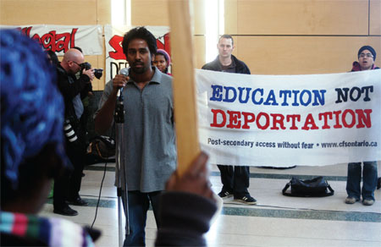
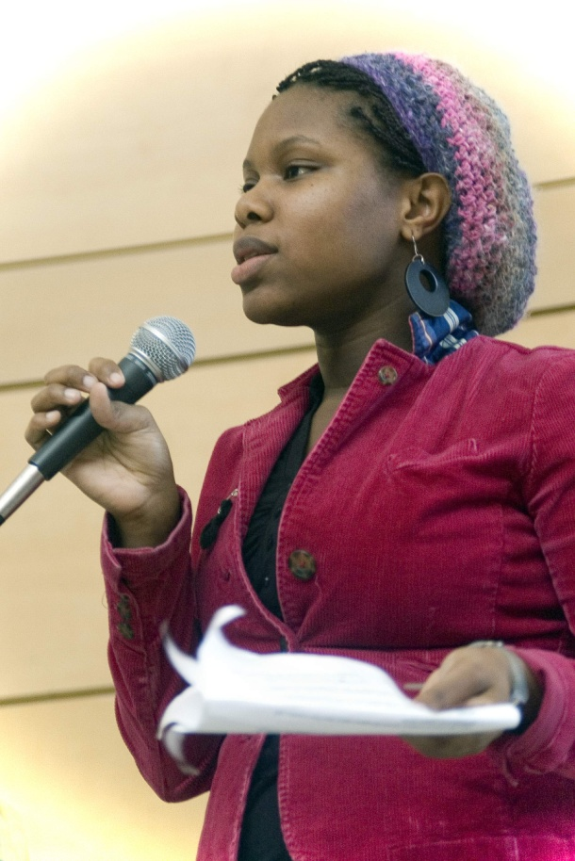

In March 2008, students rallied at York University with Sarah Leonty, a 20-year-old who arrived in Canada at age 11 from St. Lucia. She completed her first year at York but had to withdraw due to high international tuition fees. Being unable to continue as a student, Sarah was slated for deportation by immigration authorities.

In response to this order, York students, faculty and community members joined END organizers in a rally to stop her deportation and shed light on the many ways that fees exclude both status and non-status students. As a result of public pressure, Sarah was able to secure status and resume her education at York.

Just months later in September 2008, Saad Alam, a third-year student at the University of Toronto Mississauga, faced deportation along with his family to Bangladesh. Despite having lived in Canada since the age of eight, Saad was ordered to be removed in the middle of his studies because his application for status was rejected.
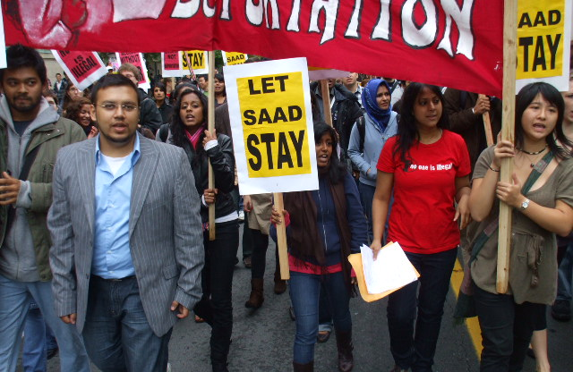

In response, friends contacted END organizers to start a campaign against his deportation. Within days, a rally of over 150 people spilled onto the main streets of the UofT campus, eventually arriving at the President’s office to demand administrative intervention. Despite the voices of so many students, UofT refused to act in support. Saad and his family were deported on October 3rd.

Compelling cases such as these are illuminating examples of the need for systemic changes beyond individual case support. In both cases, students have called on university administrators to pass a DADT policy, but York and UofT have so far refused to do so. Moreover, unlike the Ontario Education Act, no similar provincial policy exists to ensure that students in universities and colleges can access education regardless of wealth or immigration status.

We believe people have a right to learn. We believe that when people finish their education, they have a right to work and a right to participate as full members of the communities in which they live. In order to make this a reality for all people regardless of immigration status, we need to question the very idea of ‘status’ and ‘non-status’, which means fighting for a fundamental change to the immigration system. Towards that end, we will continue to struggle to make our communities safe from immigration enforcement. No longer will we accept attacks against our friends, relatives, classmates, neighbours and loved ones. We need to build from the ground up. We need to resist. And we need to win.

No One Is Illegal!
Status for All!
Discussion Questions and Activities
Discussion Questions

+ What does it mean to be non-status?
- What would you do if you broke your leg?
- Would you be able to use a food bank?
- Would you have access to public housing or emergency shelters?

+ How do you become non-status?
- How does the immigration system work?
- Why do people leave their homes to come to Canada?

+ Is education a right for all?
- Why are there tuition fees for universities and colleges but not for high schools and middle schools?
- What is the significance of the relationship between education and employment?

+ How do you make sure people are able to access rights they have in name?
- Why is it not enough to just have a policy?
- What role does community mobilization play in guaranteeing rights?

Activities

+ Myths and Realities of the Immigration System
- See: http://toronto.nooneisillegal.org/node/15

+ Breakout Groups: What Would You Do If…
- A classmate was facing deportation?
- A cousin was denied access to school?

+ Brainstorm: Services and Status
- Brainstorm a list of services that Canadian citizens take for granted, and discuss the difficulties faced by people who cannot access them because of their immigration status. Is this fair? What alternatives would non-status people have for accessing basic services?

+ Breakout Groups: Imagining Status for All
- Divide into groups and come up with creative ways to make "Status for All" a reality. Each group will present their ideas to the class, and will also have a chance to ask questions and offer suggestions to other groups

Further Resources
Articles and Reports

Drawing Detention, Creating Connections: An Interview with the No One Is Illegal Arts in Detention Group (June 2005)
http://www.bbcf.ca/_articles/detention_interview_jun05/detention_interview_jun05.htm

Access Not Fear: Non-Status Immigrants and City Services (February 2006)
https://we.riseup.net/noii_toronto/access-not-fear-non-status-immigrants+39800

Schools deployed in the war against "illegals"
(May 2006)
https://we.riseup.net/noii_toronto/schools-deployed-in-the-war-against+43400
The Right to Learn: Access to Public Education for Non-Status Immigrants (June 2008)
www.socialplanningtoronto.org/wp-content/uploads/2009/02/right_to_learn.pdf

Websites

No One Is Illegal – Toronto
www.toronto.nooneisillegal.org

Ontario Secondary Schools Teachers’ Federation
www.osstf.on.ca

